

**UNIVERSITY OF PETROLEUM & ENERGY STUDIES**

**Dehradun**

**APPLICATION CONTAINERISATION**

**Name: Shivani Tyagi**

**Course: B. TECH CSE DevOps (2018-22)**

**Roll no.: R171218097**

**Sapid: 500067253**

**Experiment-4**

**Dockerfile**

**Aim- Pushing the docker image into the docker hub**

**Step 1: Create a folder and create a html file in that folder**

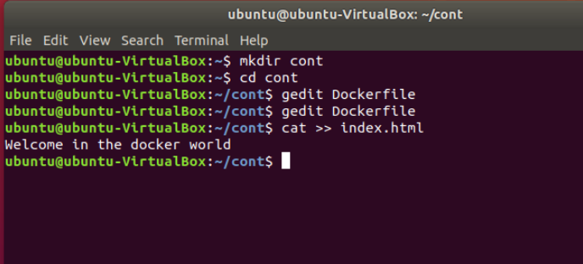

**Step 2: Write the content in the dockerfile**

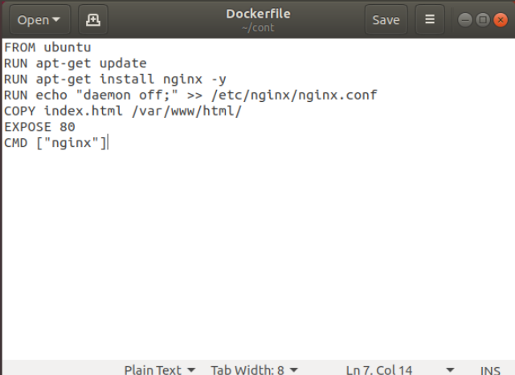

**Step 3: Now create an image using “docker build” command**

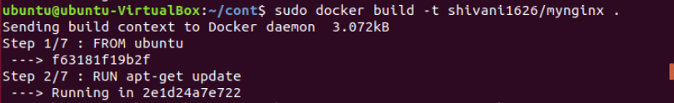

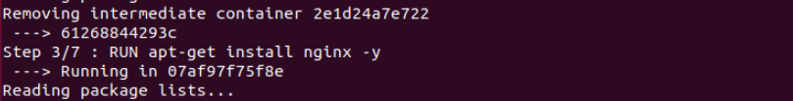

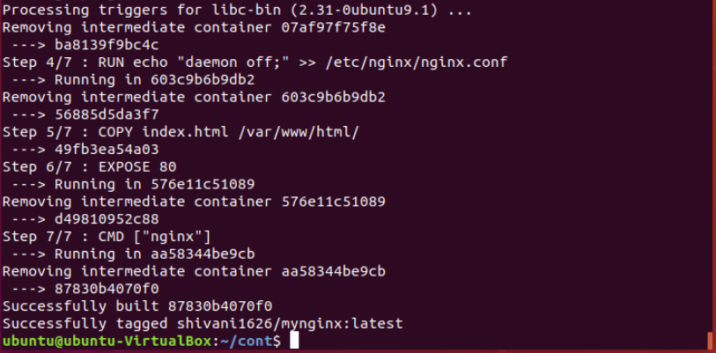

**Step 4: Login to Dockerhub**

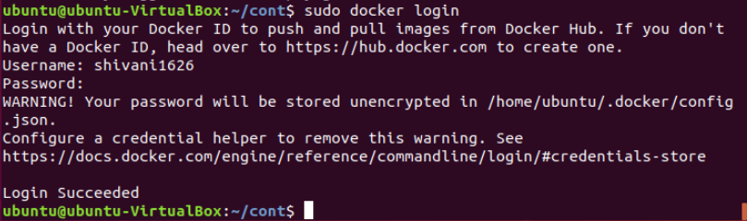

**Step 5: Now push the image to docker hub using “docker push” command**

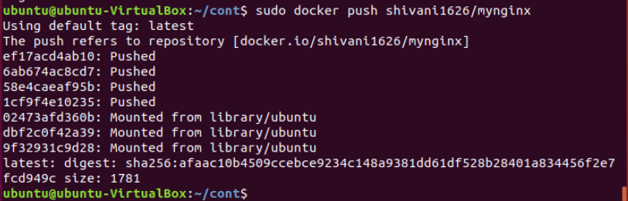

**Pushed image is visible in the dockerhub**

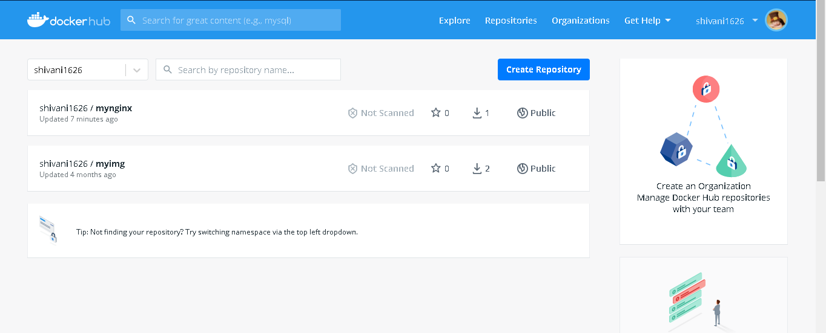

**Step 6: Remove the image locally**

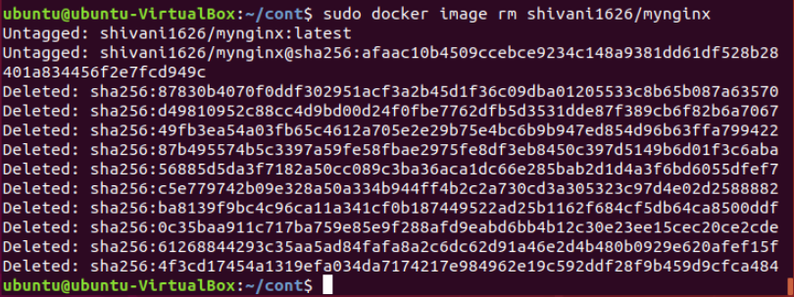

**Step 7: Pull the same image from dockerhub and launch a container**

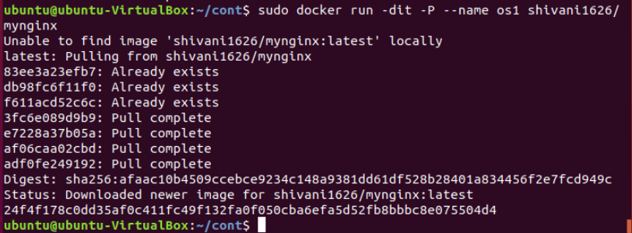

**Step 8: nginx server having 80 port has been translated**

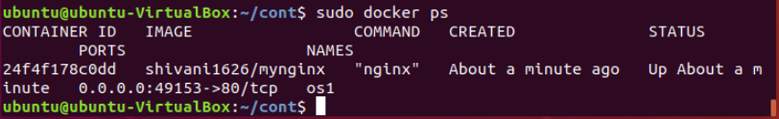

**Step 9: We can see the content of index.html file from the newly launched container**

